Dashboard and Story Report

Date | 6 feb 2026
Team ID | LTVIP2026TMIDS82987
Project Name | Strategic Product Placement Analysis: Unveiling Sales Impact with Tableau Visualization
Maximum Marks | 9 Marks

PRODUCT PLACEMENT ANALYSIS – DASHBOARD & STORY REPORT

Introduction
This project focuses on analyzing how different factors such as product category, placement position, promotions, seasonality, consumer demographics, and foot traffic influence average sales volume and pricing. The analysis is performed using Tableau to create an interactive dashboard and story that visually represent key business insights. The goal of this project is to identify which product categories and store placements contribute most effectively to sales performance.

Dashboard Overview
The dashboard provides a consolidated view of multiple analytical perspectives including sales volume by product category, consumer demographic contributions, competitor price comparison, promotion impact, seasonal trends, product positioning, and foot traffic influence. Each visualization is designed to highlight patterns and relationships between variables affecting sales.
From the dashboard, it is observed that the Clothing category slightly outperforms Electronics and Food in terms of average sales volume. Consumer demographics such as college students and families contribute almost equally to total sales, indicating a balanced customer base. Additionally, product positioning at the front of the store shows better performance compared to aisle and end-cap placements.
Promotions and seasonal effects show a moderate impact on sales, suggesting that while they improve performance, the increase is not significantly large. Overall, the dashboard offers a holistic understanding of how strategic product placement and marketing factors affect retail sales outcomes.

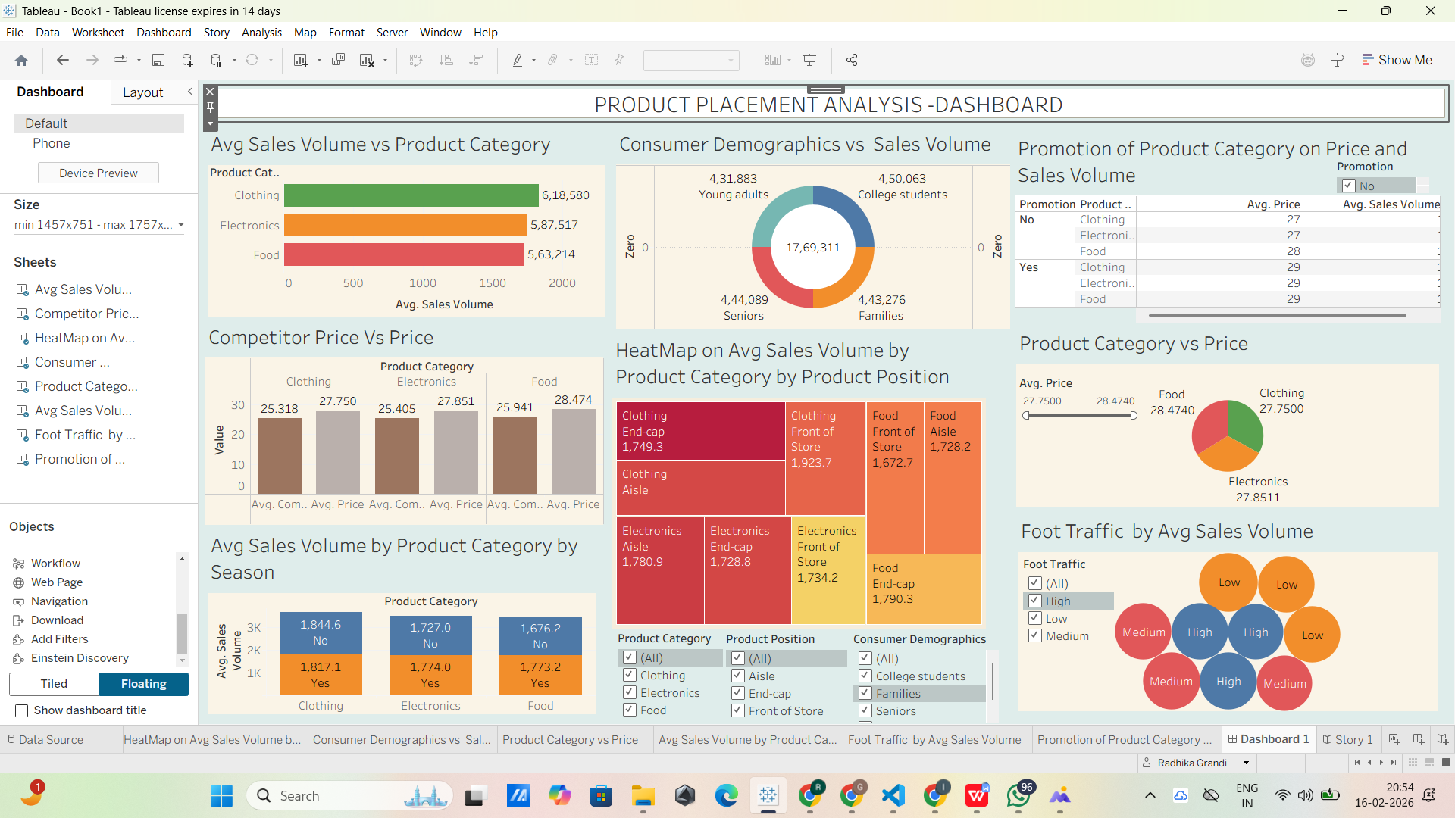

Story Analysis
The story section provides a step-by-step explanation of the insights derived from the dashboard visuals.

Sales Volume by Product Category
The analysis indicates that the Clothing category has the highest average sales volume, followed by Electronics and Food. This suggests that customers are more inclined towards purchasing clothing products compared to other categories.

Consumer Demographics vs Sales Volume
Sales contributions are relatively balanced across different demographic groups including college students, families, seniors, and young adults. However, college students show a slightly higher contribution, indicating their stronger purchasing engagement.

Promotion Impact on Price and Sales Volume
The promotion analysis reveals that promotional offers lead to a slight increase in average sales volume across all product categories. Although prices are slightly higher during promotions, customers continue to purchase, reflecting the effectiveness of promotional strategies.

Seasonal Impact on Sales
Seasonal trends show that Clothing experiences a marginal increase in sales during seasonal periods compared to Electronics and Food. This highlights the seasonal demand nature of apparel products.

Product Position Heatmap Analysis
The heatmap visualization demonstrates that products placed at the Front of Store generate higher average sales volume than those placed in aisles or end-cap positions. This confirms the importance of strategic product placement in influencing customer buying behavior.

Foot Traffic vs Sales Volume
Foot traffic analysis shows that areas with high customer movement produce slightly higher sales volume. Medium and low traffic zones generate comparatively lower sales, indicating that customer exposure plays a crucial role in driving purchases.
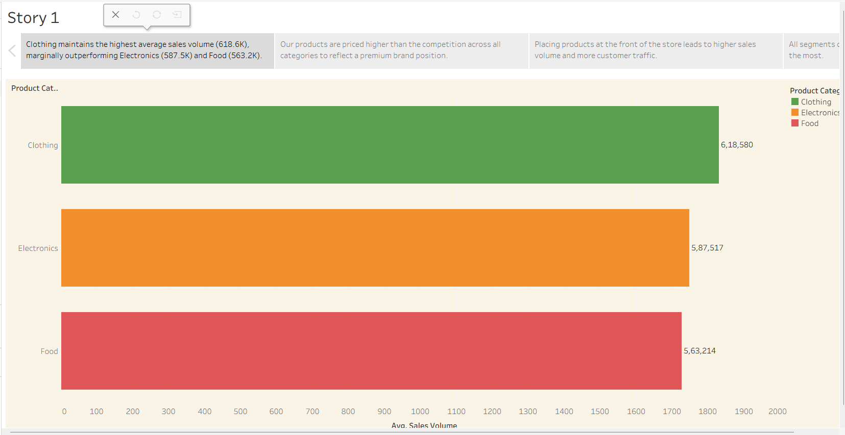

Key Insights
Based on the overall dashboard and story analysis, several important insights can be derived:
- Clothing category consistently shows the highest sales performance.
- Front-of-store placement significantly enhances product visibility and sales.
- Promotions create a moderate uplift in sales volume across all categories.
- Seasonal trends slightly favor clothing products over others.
- High foot traffic areas contribute to better sales outcomes.
- Consumer demographics contribute almost equally, with college students showing a slight lead.

Conclusion
In conclusion, the analysis highlights that strategic product placement combined with promotional activities and seasonal planning can positively influence sales performance. Among all categories, Clothing benefits the most from optimal placement and seasonal demand. Retailers should prioritize placing high-demand products in front-of-store locations and leverage promotions during key seasons to maximize sales. The dashboard and story together provide meaningful, data-driven insights that can support better merchandising and marketing decisions.

Tableau Public Links
Dashboard Link:
https://public.tableau.com/views/Book1_17712426033970/Dashboard1?:language=en-GB&:sid=&:redirect=auth&:display_count=n&:origin=viz_share_link
Story Link:
https://public.tableau.com/views/Book1_17712426033970/Story1?:language=en-GB&:sid=&:redirect=auth&:display_count=n&:origin=viz_share_link

